**EXPERIMENT-2**

AIM

To execute General Purpose File Management and Linking commands.

**$cal :** It shows the calendar of the current month.

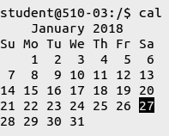

**$cal -y :** Displays the calendar of the entire current year.



**$cal <month_number> <year> :** Displays the calendar of the specified moth of the specified year.

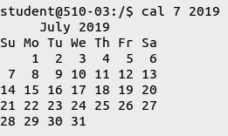

**$who :** Displays all the users of the current system.

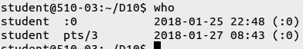

**$whoami :** Displays the user you are currently using.



**$echo :** Works like the print command. Eg: **$echo** “Hello” OR **$echo** Hello

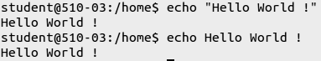

**$date :** Displays the current date,month,day and the time.



**$time :** Displays the time statistics about the running of the command.

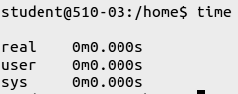

**$uname :** Displays the user name.



**$bc :** bc stands for Basic Calculator

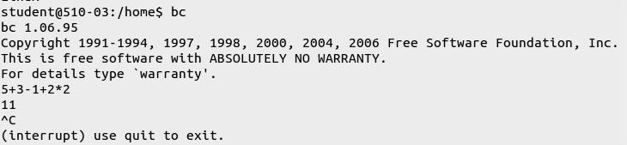

**$passwd :** Allows you to change the password of the current system.



**cat**

The **cat** (short for “concatenate“) command is one of the most frequently used command in **Linux**/Unix like operating systems. **cat** command allows us to create single or multiple files, view contain of file, concatenate files and redirect output in terminal or files.

**mkdir**

Makes a new directory.

**head**

The head command reads the first few lines of any text given to it as an input and writes them to standard output.

**head -c int filename**

Reads the desired number of bytes and writes them as standard output.

**tail**

The tail command is a command-line utility for outputting the last part of files given to it via standard input. It writes results to standard output. ... It may also be used to follow a file in real-time and watch as new lines are written to it.

**tail -c filename**

It gives the number of bytes.

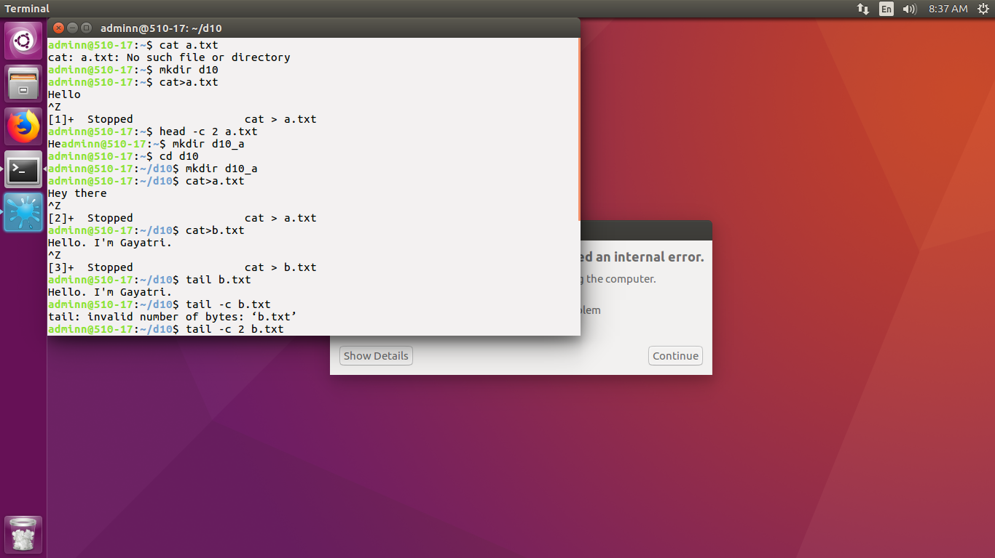

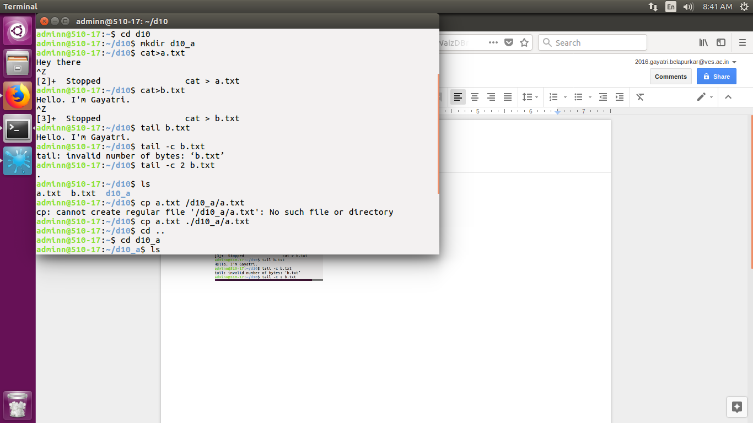

**whereis ls :**

Gives the complete location of the bin file in linux.

**which ls :**

Shows the location of the bin file in linux.

**users :**

Gives active user name.

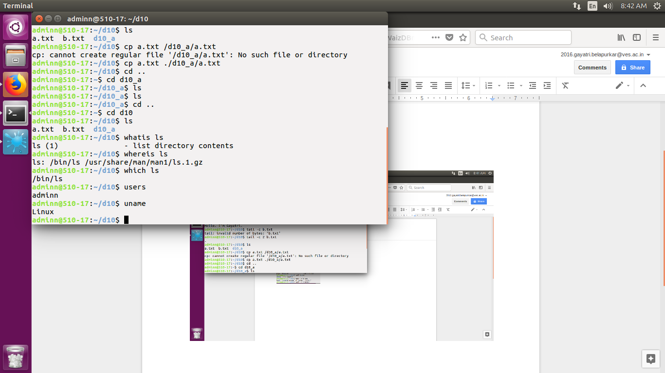

**Ls -l x.txt**

First hyphen : Type of file

* : general purpose file

d : directory

l : link

Next 3 : for owners or users who have created the file

Next 3 : for group

Last 3 : for others

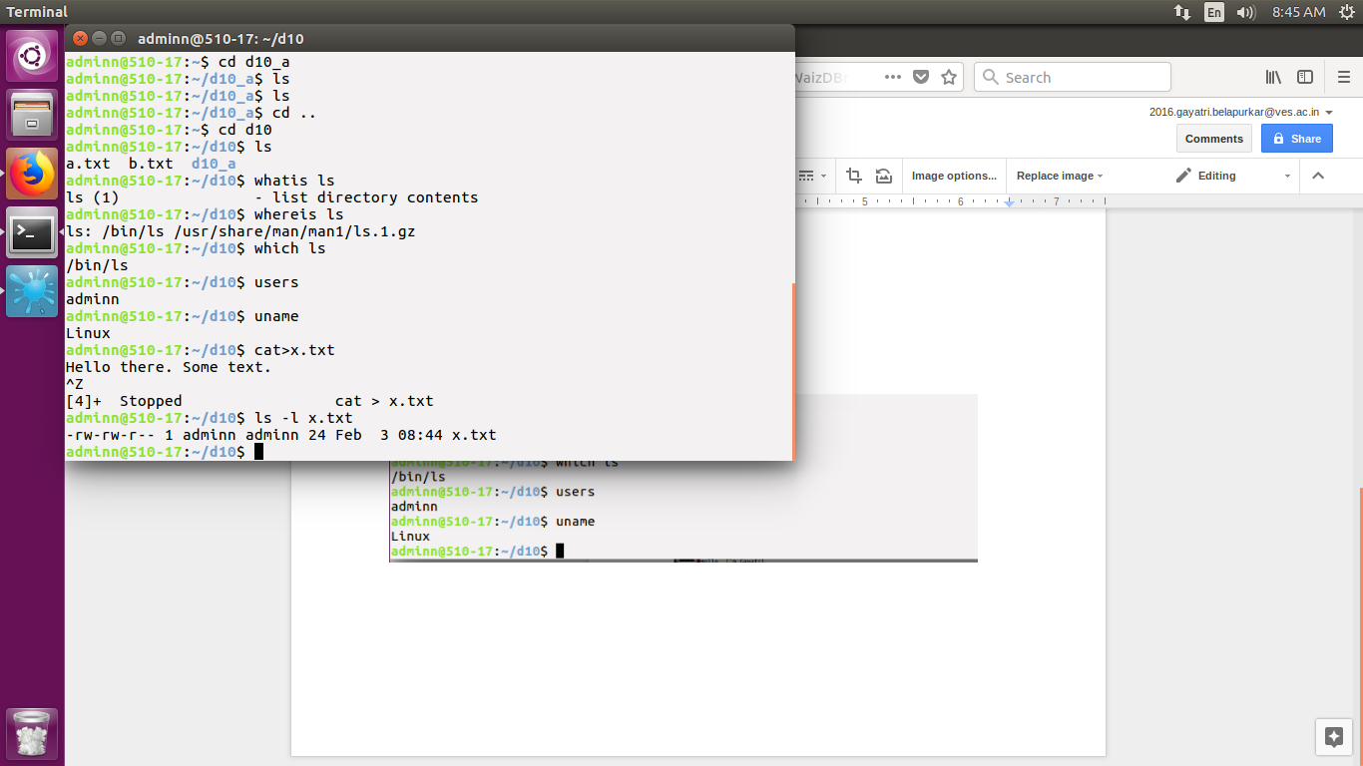

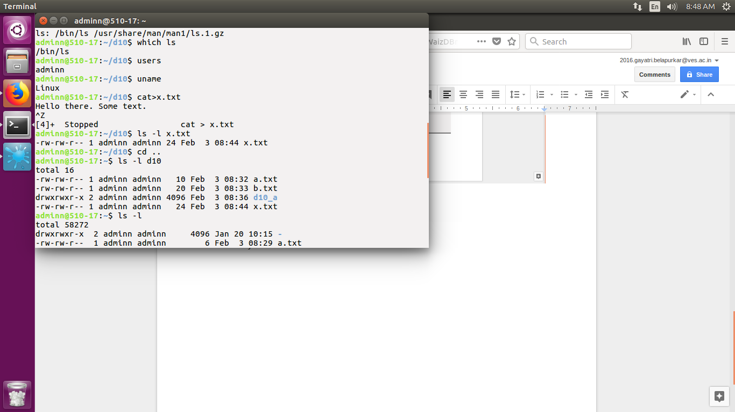

**chmod : for changing permissions**

o-others

u-owner/user

g-group

* Adds permission
* Removing permission

= Sets permission

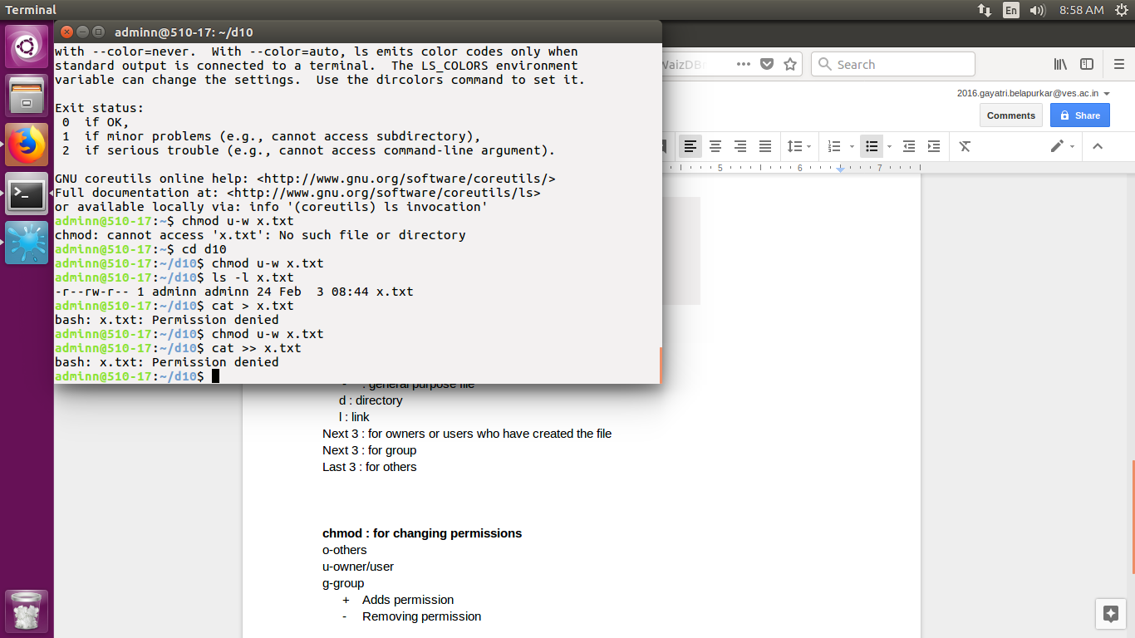

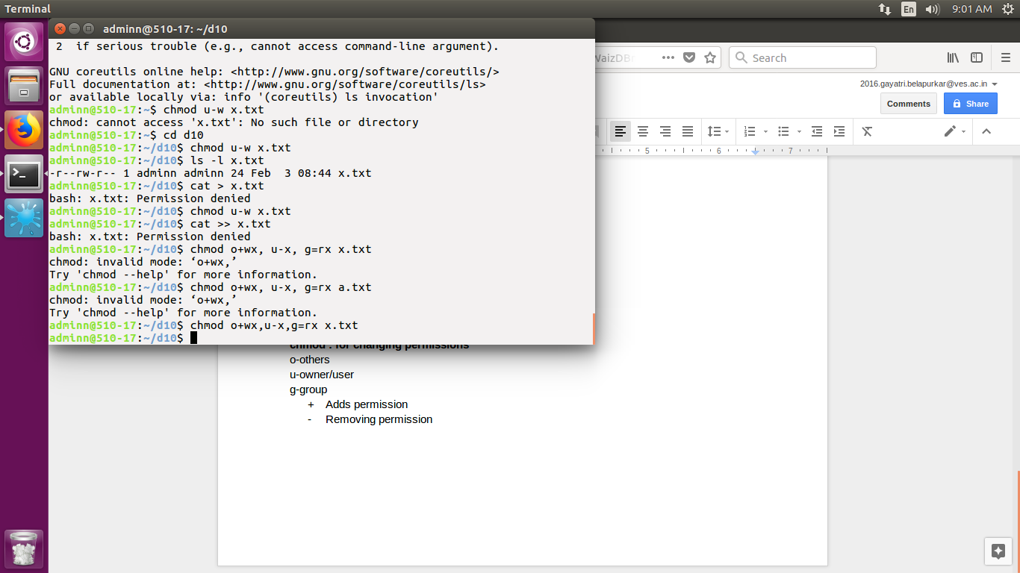

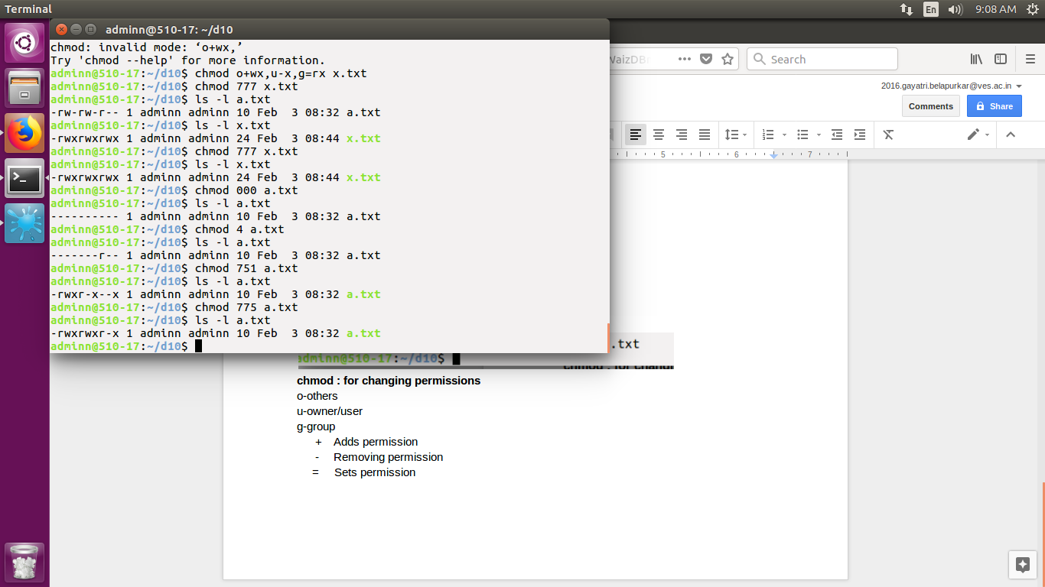

**Ln a.txt b.txt**

Creates different names for the same file

Types:

* Soft link/symbolic link -s
* Hard link

-i is for inode. I-node is a unique identification.

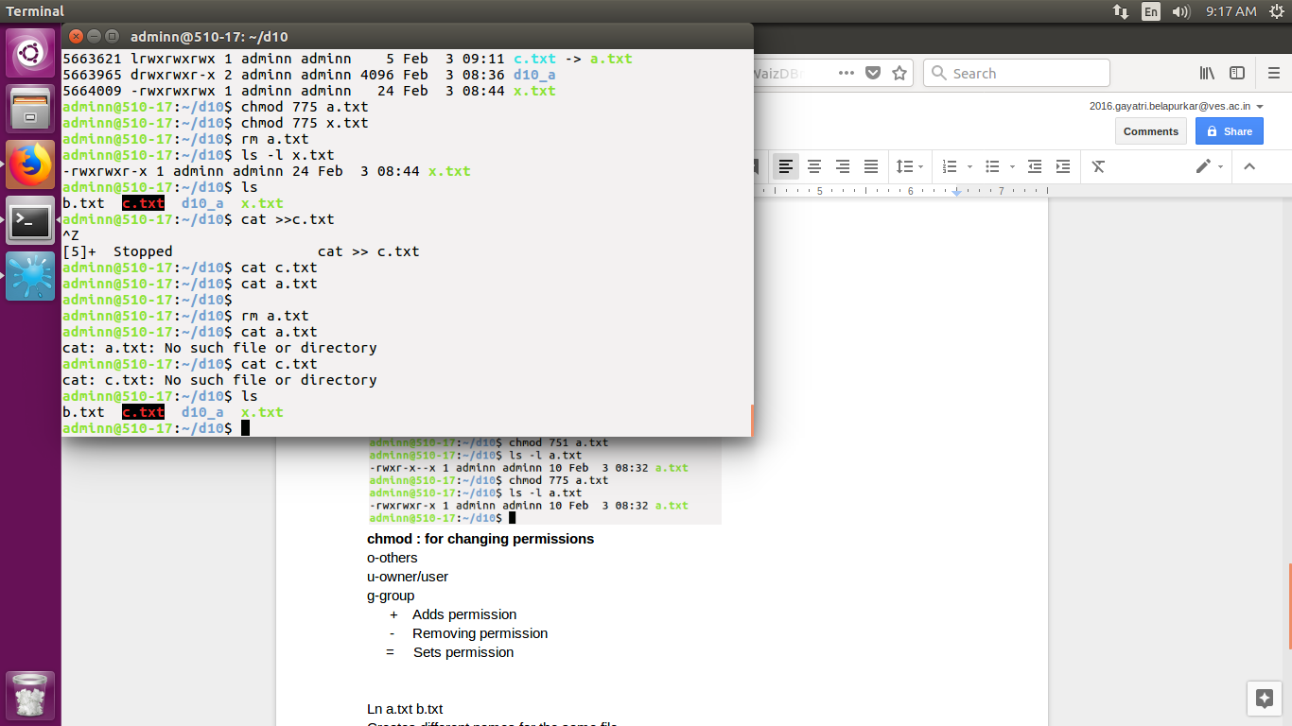

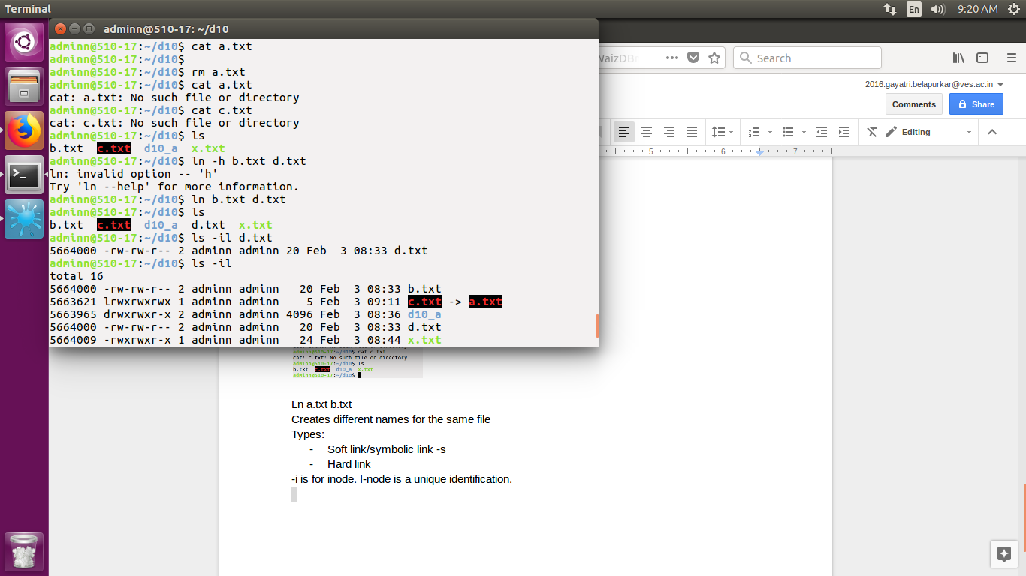

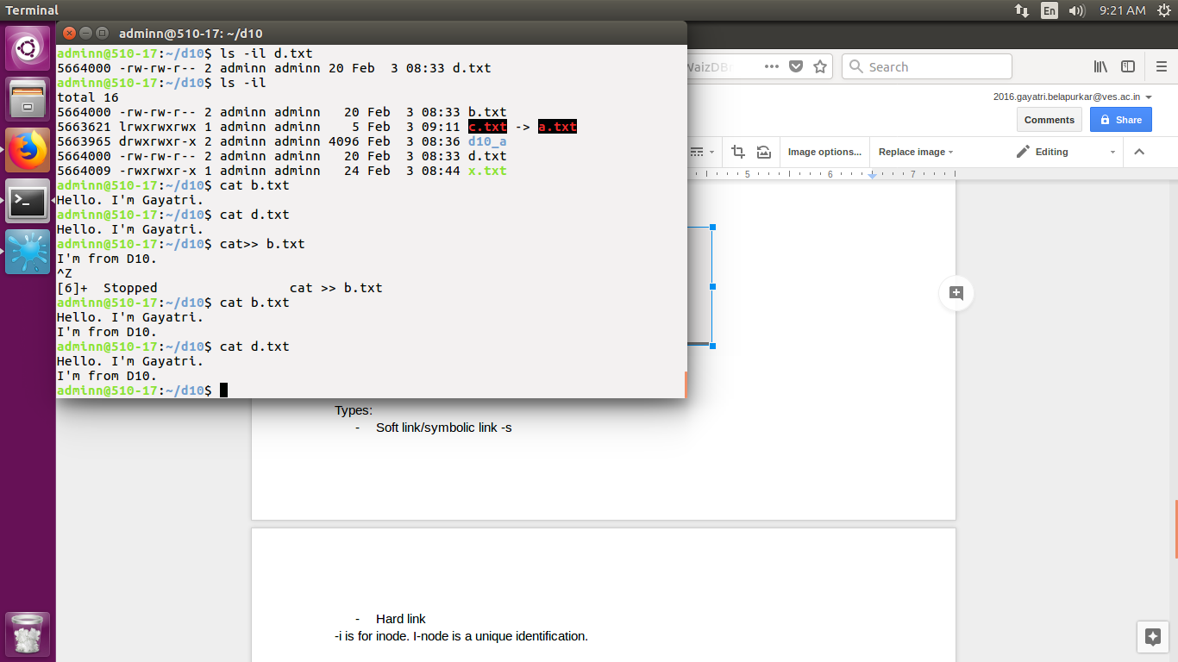

**I/O redirection :**

stdin(0) - input

stdout(1) - output

strerr(2) - error

Input-output redirection transfers or redirects default input-output streams to the given file.

i/p <

o/p >

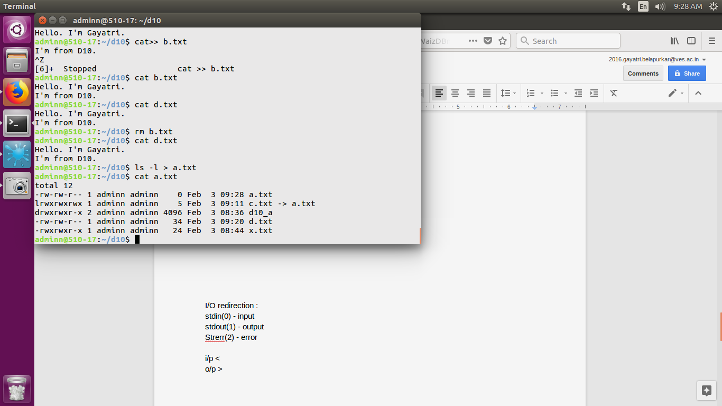

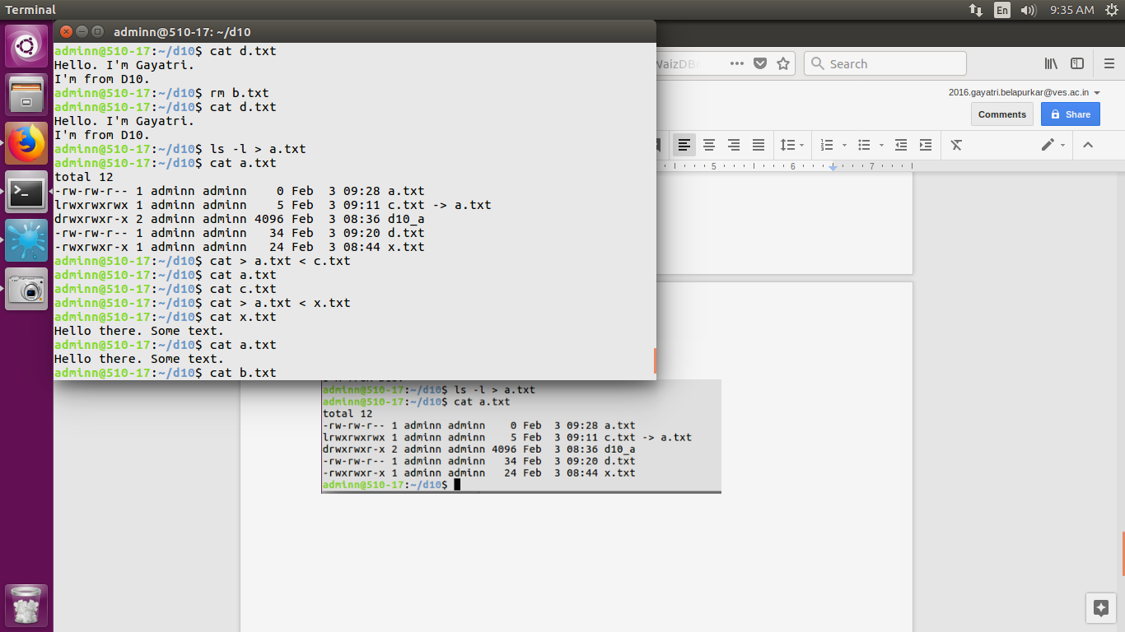

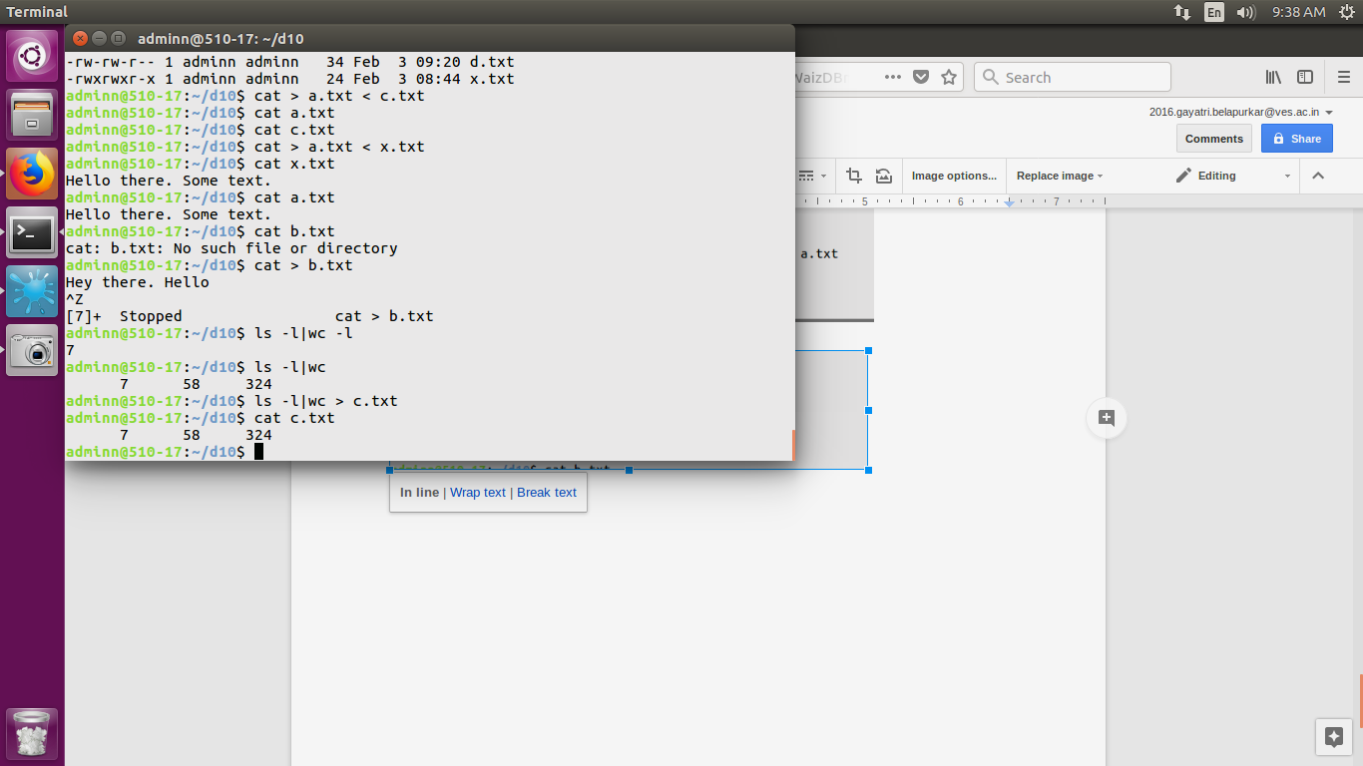

**CONCLUSION**

Thus, the General Purpose File Management and Linking commands have been studied and executed.